Name – Hritik Anand

Student ID – 104185477

Unit – Requirement Analysis & Modelling

Use case descriptions

1. Creates Customer Account

|  |  |
| --- | --- |
| User case name | Create customer account |
| Scenario | Create online customer account |
| Triggering event | New customer wants to set up an account |
| Brief description | Online customer creates customer account by entering basic information and then following up with the required conditions |
| Actors | Customer |
| Related use cases | Might be involved while searching for appointment enquiries |
| Stakeholders | Business Operators, system operators |
| Preconditions | Customer account subsystem must be available.  Authorization service must be available |
| Postconditions | Customer account must be created  Authorization must be done  Customer can access the platform services |
| Flow of activities | |  |  | | --- | --- | | Actor | Customer | | 1. Customer desire to make customer account. 2. Customer enters basic details like address, email, phone number. 3. Customer enters OTP for authorization and validation | * 1. System handles new.   customer.  2.2 System prompts for customer details like email, addresses.  3.1 System creates account.  3.2 System verifies authorization.  3.3 System returns validation. | |
| Exception conditions | Basic customer details are not complete.  Validation Code is invalid. |

System Sequence Diagram

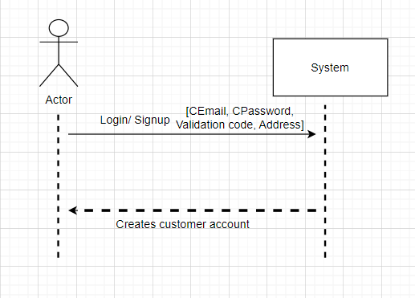

1. Making Reservation

|  |  |
| --- | --- |
| User case name | Making reservation |
| Scenario | Making a reservation online |
| Triggering event | Customer wants to search availability and make reservation |
| Brief description | Online customer searches for availability. He/she checks the most suitable date/time for them to visit. |
| Actors | Customer |
| Related use cases | Modify reservation  Cancel reservation  Check reservation status |
| Stakeholders | Business Operators, customer |
| Preconditions | Customer is registered or has an account already.  The customer has access to reservation platform.  Necessary information, such as availability, pricing, is provided to the customer. |
| Postconditions | The customer has successfully made a reservation for the desired service.  The business has the reservation details recorded and thus can prepare for customer’s arrival. |
| Flow of activities | |  |  | | --- | --- | | Actor | Customer | | 1. Signing up and searching for availability 2. Choosing Reservation type 3. Enter information | * 1. Check existing reservations.   2. Display all other availabilities.   2.1 Provides remaining date/time options for customer to make a choice.  3.1 Make reservation  3.2 Initiates for required steps like payment. | |
| Exception conditions | 1. If there are technical issues or system failures during the reservation process, the customer may not be able to complete the reservation. 2. If the customer encounters errors or validation issues while entering the reservation information, the system should display appropriate error messages and allow the customer to correct the information. |

System sequence Diagram

